Test Case: tc002_SPX_Dev5_Crear_Requisicion_Spot_Con_FAD_Tipo_Cobro_CC
Step 1 - Enter username and password and click to button Enter : Credentials Entered
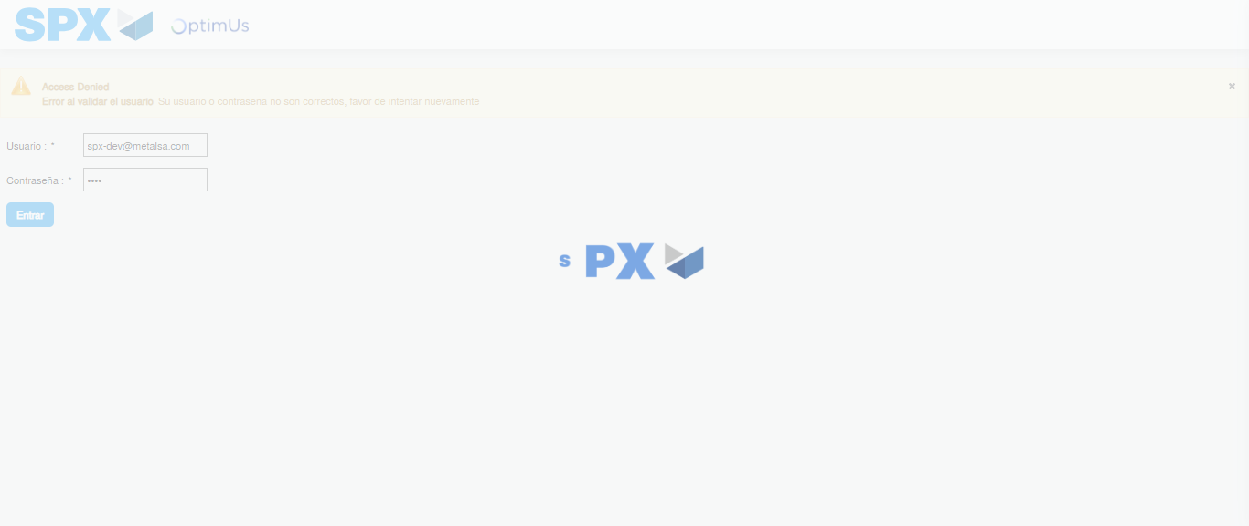Image file-name: QC_Testing-tc002_SPX_Dev5_Crear_Requisicion_Spot_Con_FAD_Tipo_Cobro_CC-1785343845436

Step 2 - Select to UEN and Access to Spot Buy Requisitions : UEN Correctly selected and Correct access
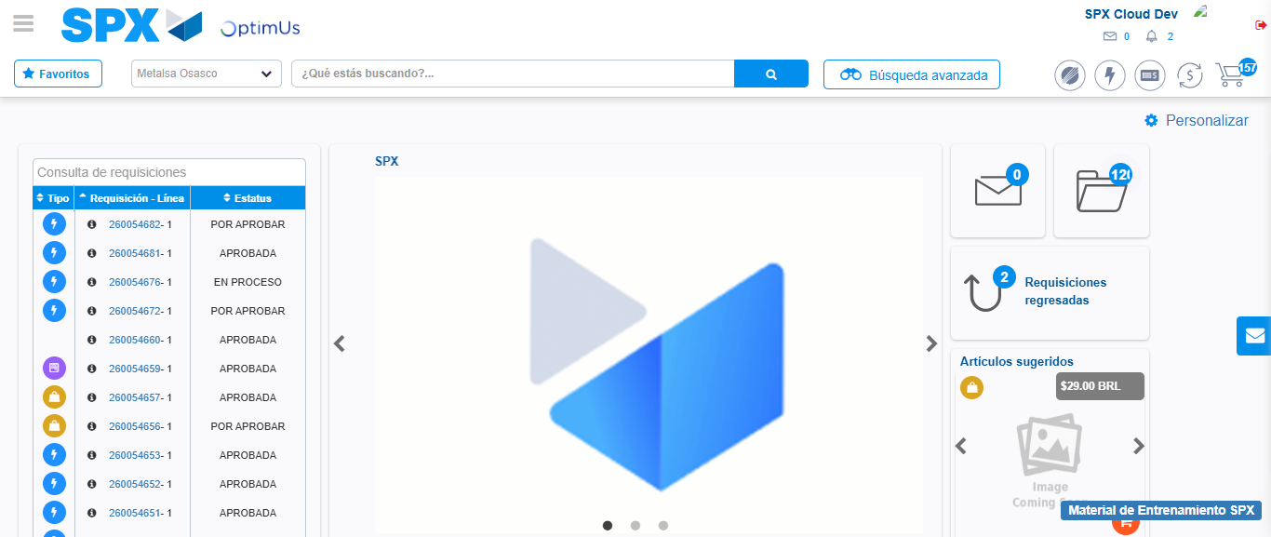Image file-name: QC_Testing-tc002_SPX_Dev5_Crear_Requisicion_Spot_Con_FAD_Tipo_Cobro_CC-1785343871146

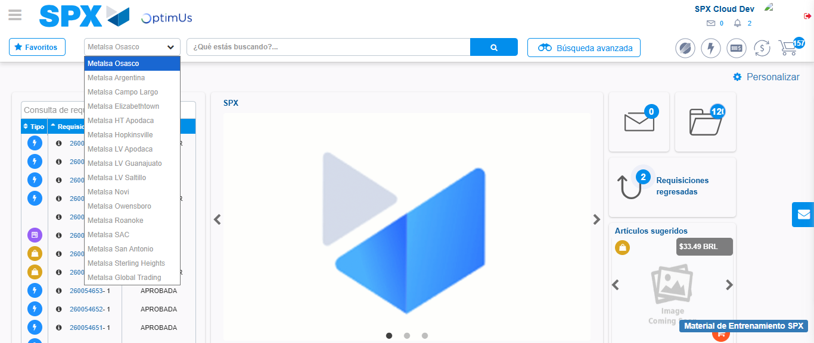Image file-name: QC_Testing-tc002_SPX_Dev5_Crear_Requisicion_Spot_Con_FAD_Tipo_Cobro_CC-1785343873766

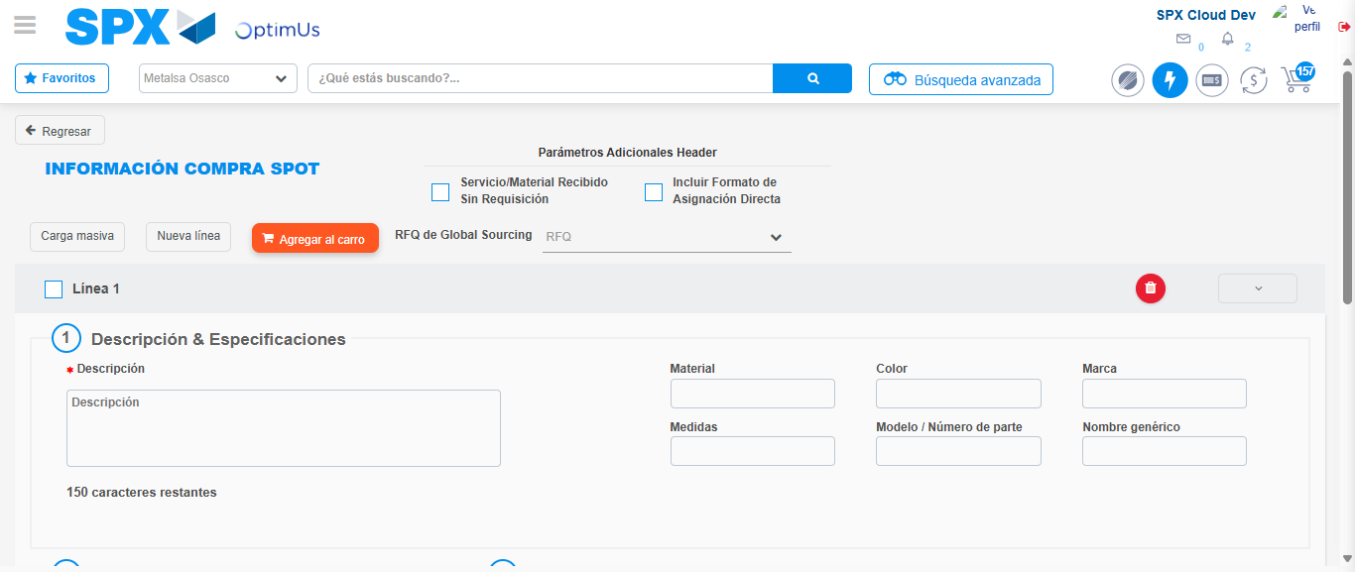Image file-name: QC_Testing-tc002_SPX_Dev5_Crear_Requisicion_Spot_Con_FAD_Tipo_Cobro_CC-1785343901921

Step 3 - Add FAD to Requisition: FAD Successfully Added
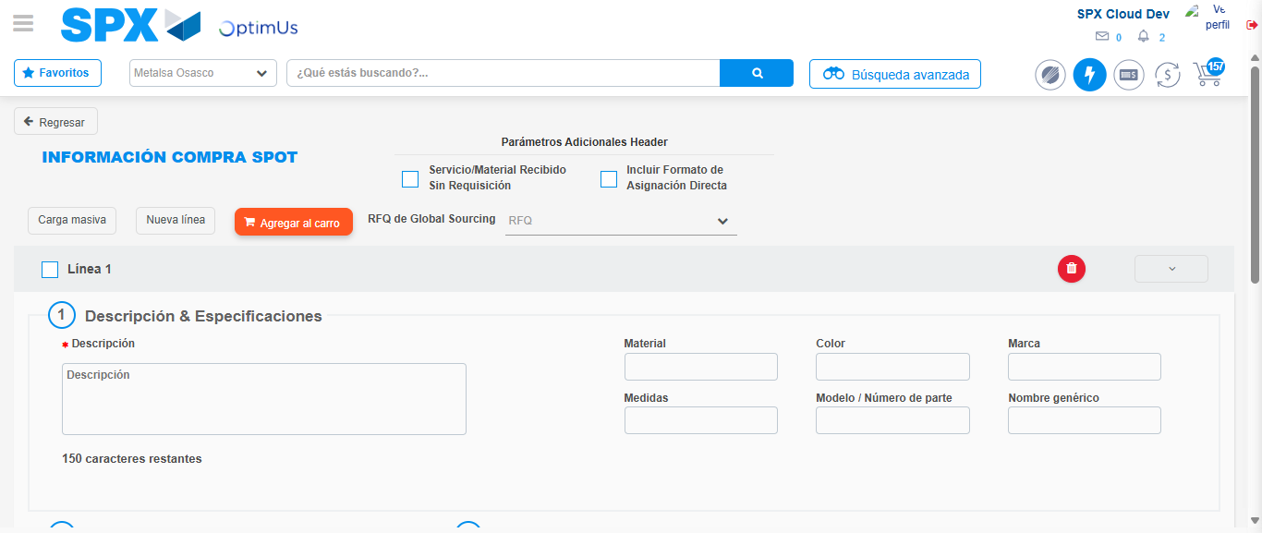Image file-name: QC_Testing-tc002_SPX_Dev5_Crear_Requisicion_Spot_Con_FAD_Tipo_Cobro_CC-1785343902231

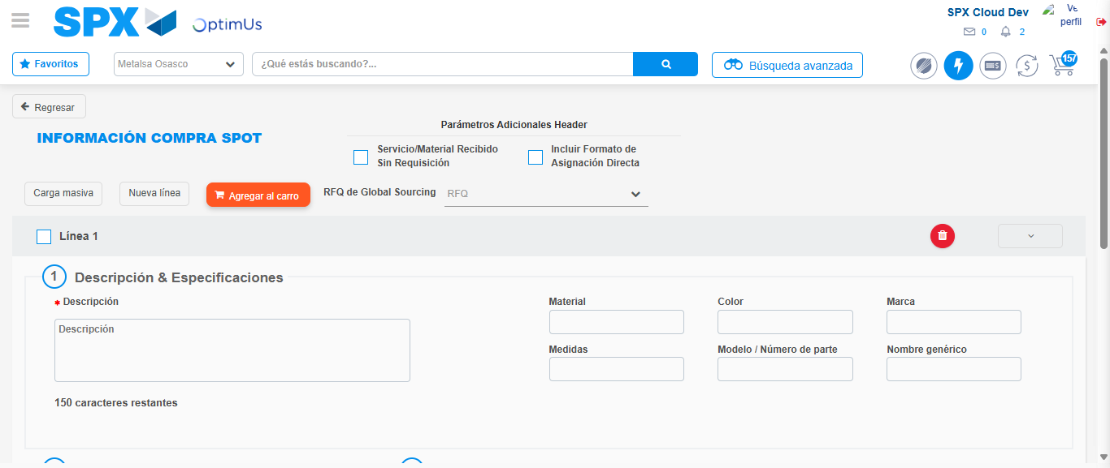Image file-name: QC_Testing-tc002_SPX_Dev5_Crear_Requisicion_Spot_Con_FAD_Tipo_Cobro_CC-1785343902484

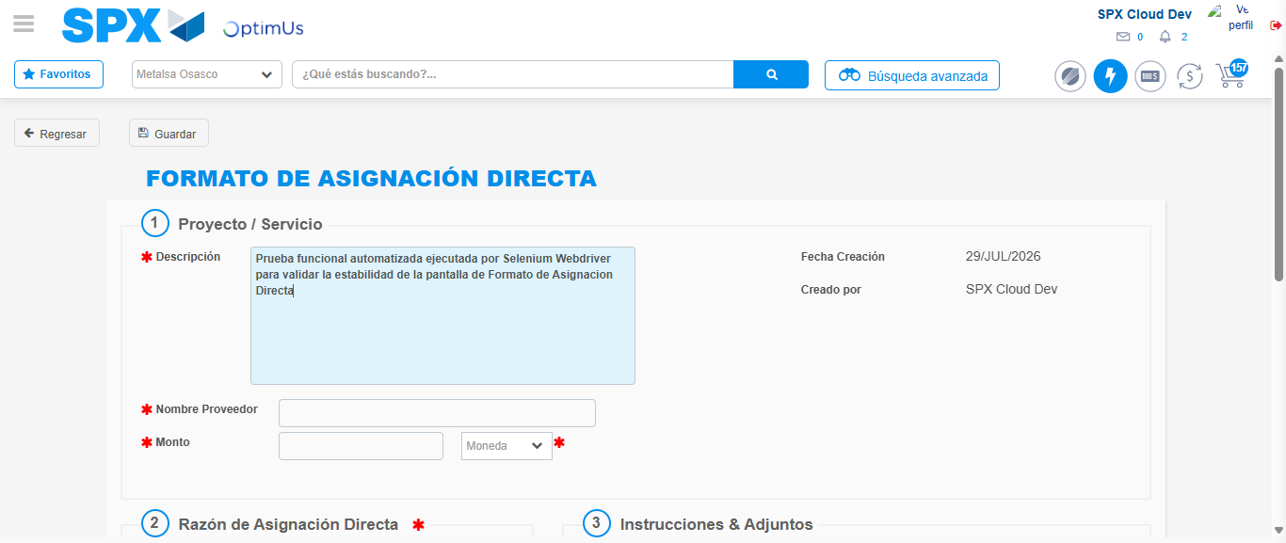Image file-name: QC_Testing-tc002_SPX_Dev5_Crear_Requisicion_Spot_Con_FAD_Tipo_Cobro_CC-1785343905162

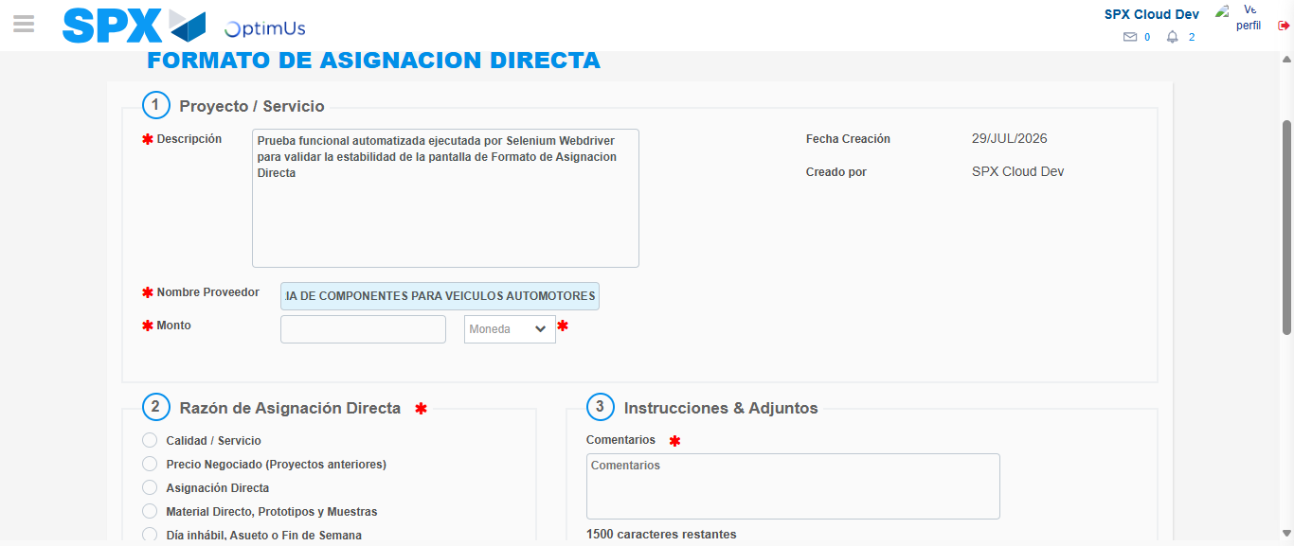Image file-name: QC_Testing-tc002_SPX_Dev5_Crear_Requisicion_Spot_Con_FAD_Tipo_Cobro_CC-1785343913784

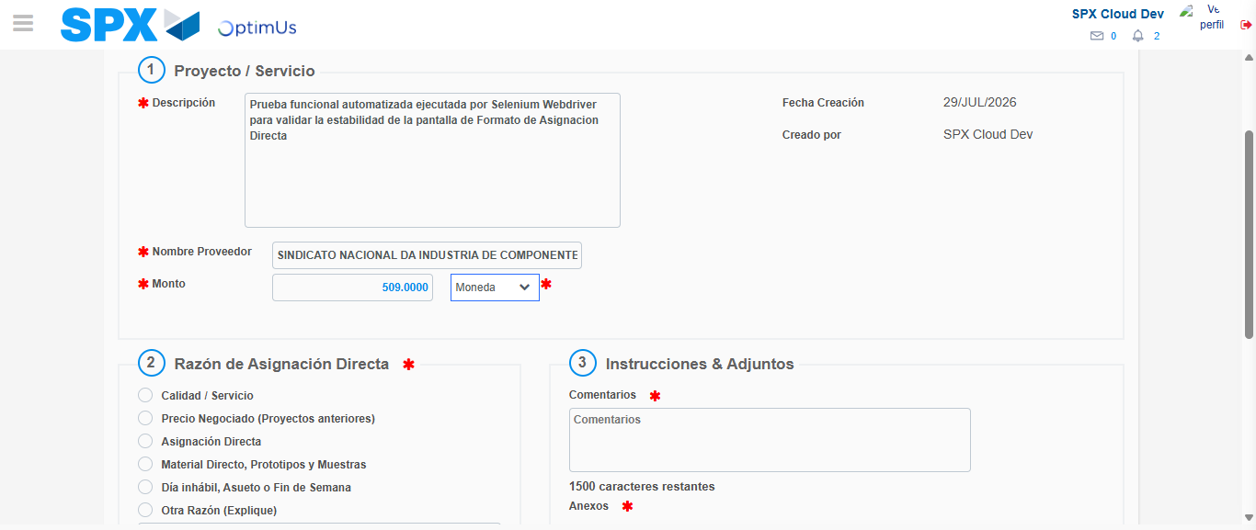Image file-name: QC_Testing-tc002_SPX_Dev5_Crear_Requisicion_Spot_Con_FAD_Tipo_Cobro_CC-1785343914129

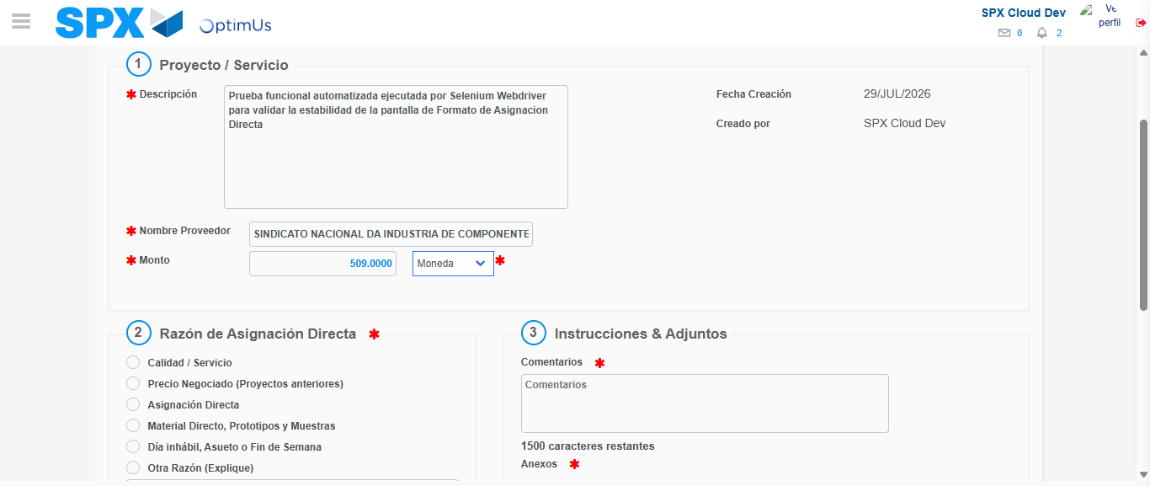Image file-name: QC_Testing-tc002_SPX_Dev5_Crear_Requisicion_Spot_Con_FAD_Tipo_Cobro_CC-1785343914362

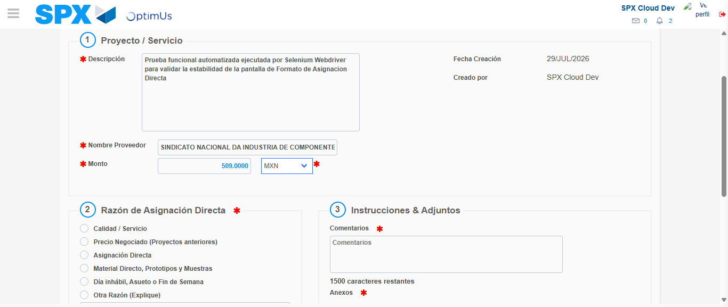Image file-name: QC_Testing-tc002_SPX_Dev5_Crear_Requisicion_Spot_Con_FAD_Tipo_Cobro_CC-1785343914679

Image file-name: QC_Testing-tc002_SPX_Dev5_Crear_Requisicion_Spot_Con_FAD_Tipo_Cobro_CC-1785343914877

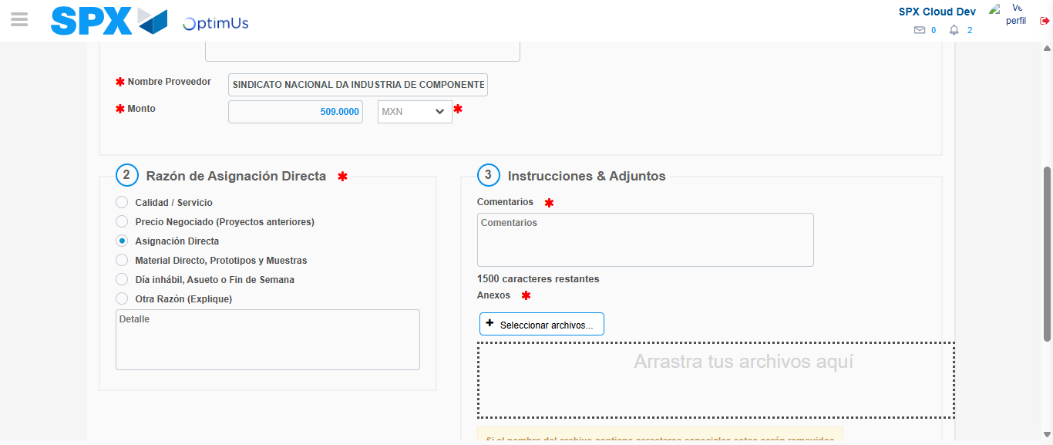Image file-name: QC_Testing-tc002_SPX_Dev5_Crear_Requisicion_Spot_Con_FAD_Tipo_Cobro_CC-1785343915683

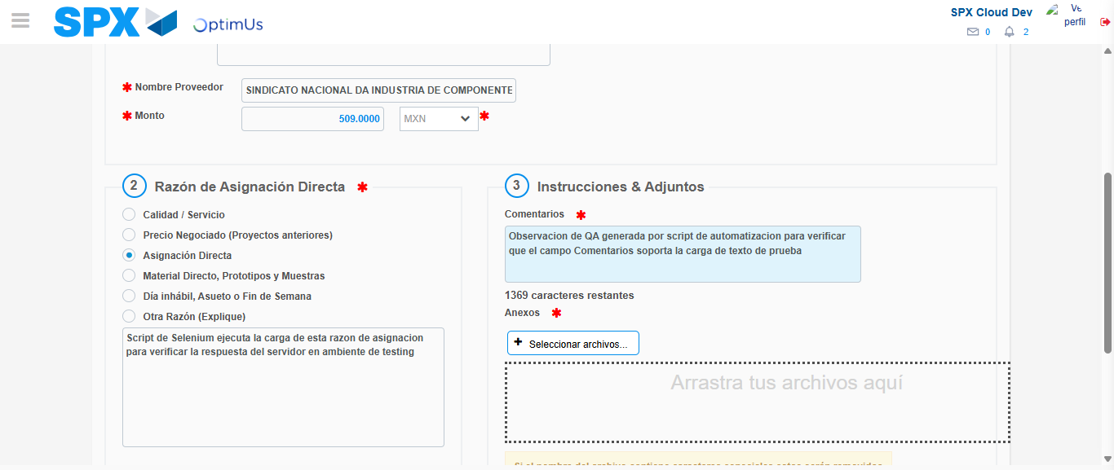Image file-name: QC_Testing-tc002_SPX_Dev5_Crear_Requisicion_Spot_Con_FAD_Tipo_Cobro_CC-1785343926606

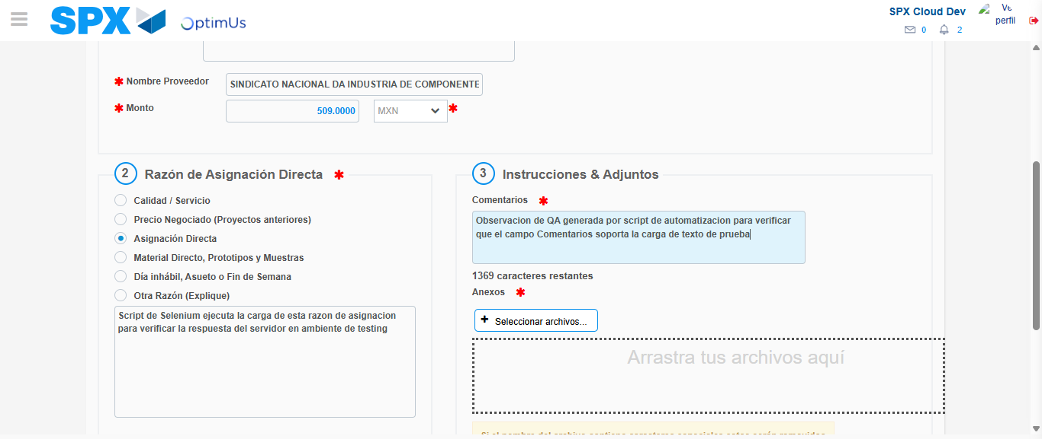Image file-name: QC_Testing-tc002_SPX_Dev5_Crear_Requisicion_Spot_Con_FAD_Tipo_Cobro_CC-1785343927186

Step 4 - Data Capture Spot Buy Requisition: Data captured correctly
Image file-name: QC_Testing-tc002_SPX_Dev5_Crear_Requisicion_Spot_Con_FAD_Tipo_Cobro_CC-1785343902231

Image file-name: QC_Testing-tc002_SPX_Dev5_Crear_Requisicion_Spot_Con_FAD_Tipo_Cobro_CC-1785343902484

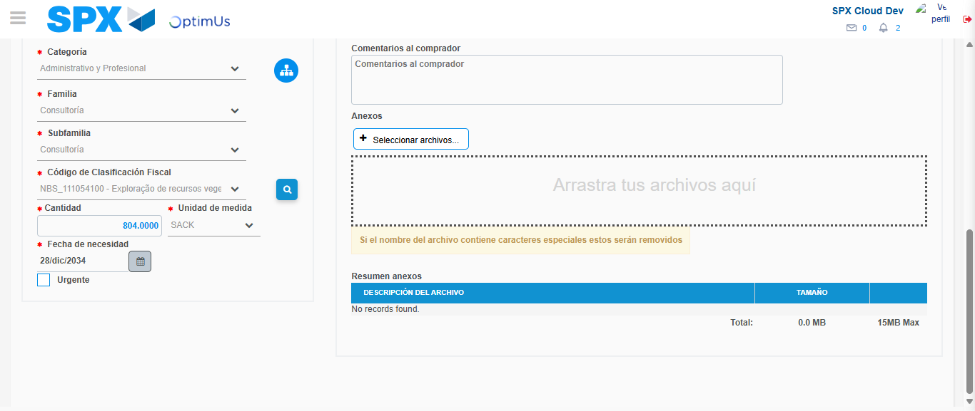Image file-name: QC_Testing-tc002_SPX_Dev5_Crear_Requisicion_Spot_Con_FAD_Tipo_Cobro_CC-1785343942950

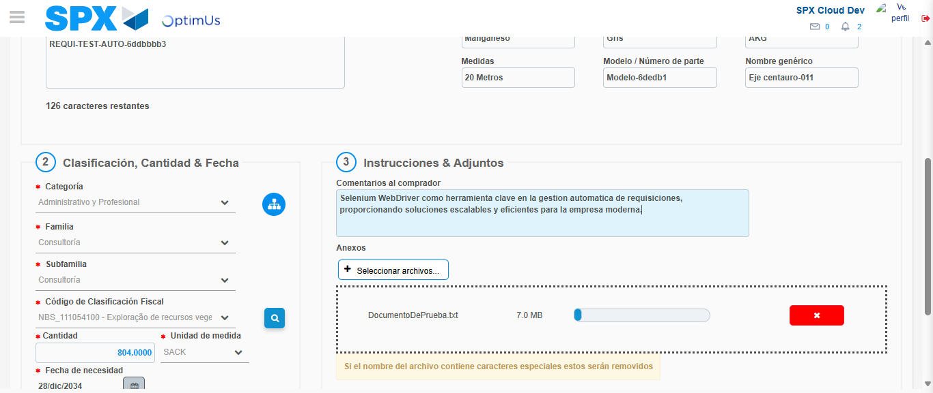Image file-name: QC_Testing-tc002_SPX_Dev5_Crear_Requisicion_Spot_Con_FAD_Tipo_Cobro_CC-1785343943671

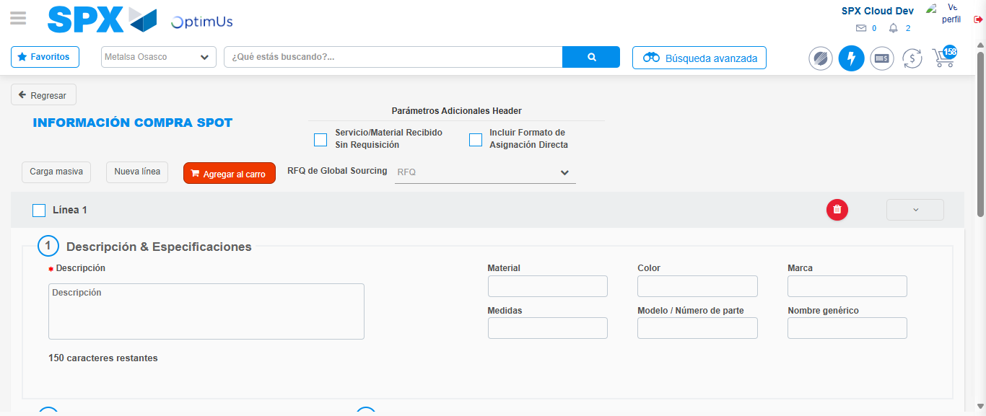Image file-name: QC_Testing-tc002_SPX_Dev5_Crear_Requisicion_Spot_Con_FAD_Tipo_Cobro_CC-1785343951543

Step 8 - Return to Main Page SPX : Return to Main Page SPX
Image file-name: QC_Testing-tc002_SPX_Dev5_Crear_Requisicion_Spot_Con_FAD_Tipo_Cobro_CC-1785343871146

Image file-name: QC_Testing-tc002_SPX_Dev5_Crear_Requisicion_Spot_Con_FAD_Tipo_Cobro_CC-1785343873766

Image file-name: QC_Testing-tc002_SPX_Dev5_Crear_Requisicion_Spot_Con_FAD_Tipo_Cobro_CC-1785343901921

Image file-name: QC_Testing-tc002_SPX_Dev5_Crear_Requisicion_Spot_Con_FAD_Tipo_Cobro_CC-1785343953740

Image file-name: QC_Testing-tc002_SPX_Dev5_Crear_Requisicion_Spot_Con_FAD_Tipo_Cobro_CC-1785343953921

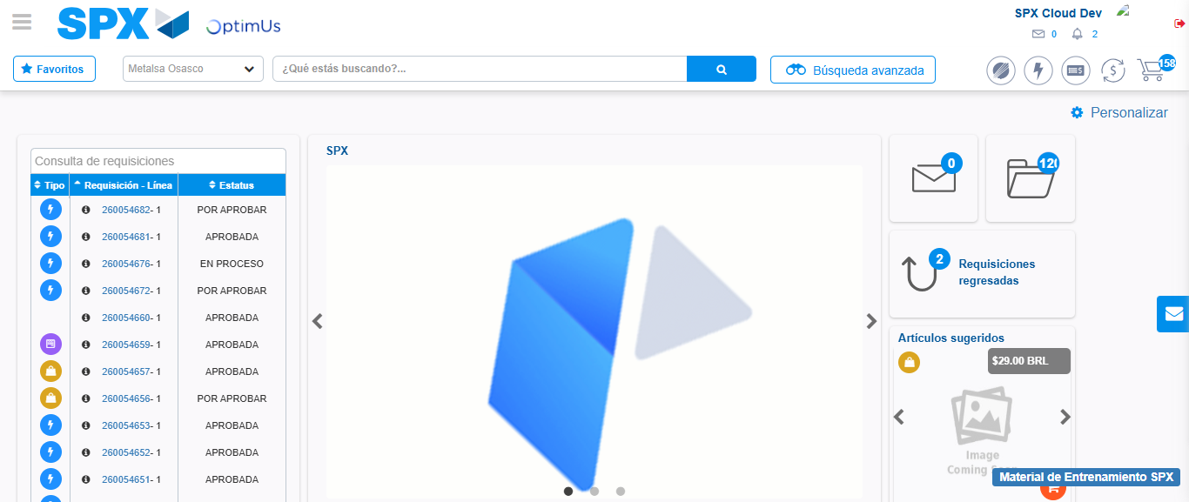Image file-name: QC_Testing-tc002_SPX_Dev5_Crear_Requisicion_Spot_Con_FAD_Tipo_Cobro_CC-1785343974920

Step 9 - Log Out : Log Out SPX
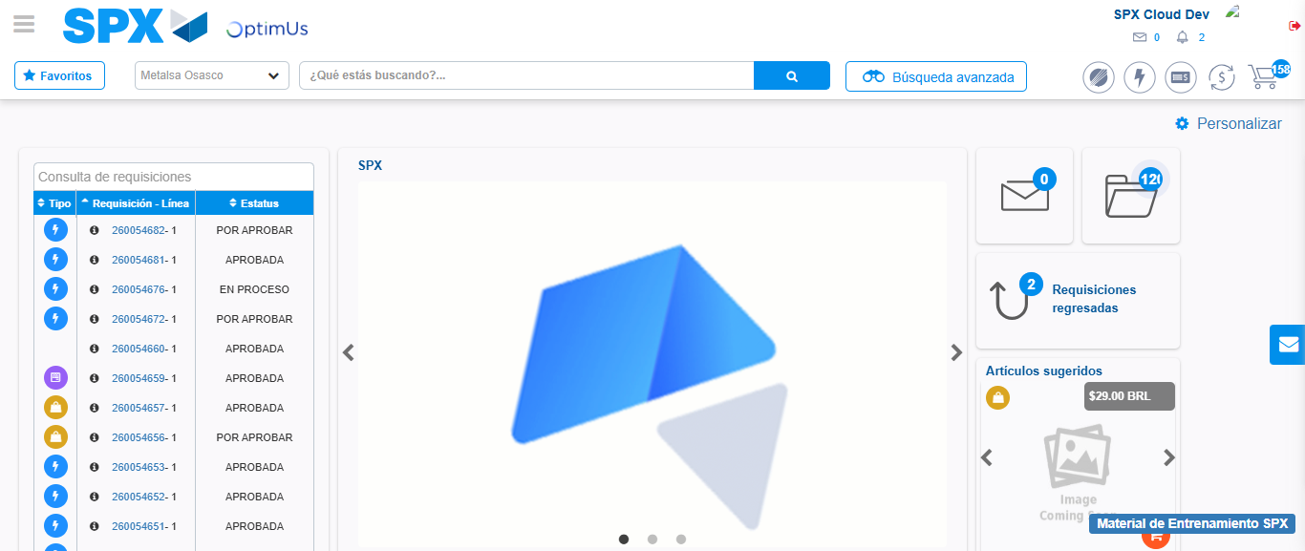Image file-name: QC_Testing-tc002_SPX_Dev5_Crear_Requisicion_Spot_Con_FAD_Tipo_Cobro_CC-1785343975248

